SPECIFICATION OF SUMMATIVE ASSESSMENT FOR TERM 3
Review of summative assessment for term 3

Duration of the summative assessment – 40minutes
Listening – 10 minutes
Reading – 10 minutes
Writing – 20 minutes
Speaking task is conducted separately.
Total marks- 24

The structure of the summative assessment

This Summative Assessment consists of 14 questions: listening, reading, writing and speaking. Different types of tasks are used in the Summative Assessment for the term.
Reordering tasks require learners to put options in the order of mentioning.
Open-ended tasks require learners to follow instructions of the task, answer questions in words, expressions and sentences.
True/False tasks require learners to indicate whether the provided option right or wrong.
Sentence completion tasks require learners to complete the sentence with suitable information taken from the text following the sentence structure.
Transcript for listening task is taken from https://learnenglishteens.britishcouncil.org/study-break/video-zone/five-social-media-musts-teens and can be found after the mark scheme.
The content of the summative assessment for the 3 term should be selected on topics “Reading for pleasure” or/and “Entertainment and Media” or/and “Natural Disasters”.

Characteristic of tasks for summative assessment for the 3 term
Unit | Strand | Learning objective | *Total number of questions | *Question № | *Type of question | *Task description | Time | Total marks
Reading for pleasure  Entertainment and Media.  Natural Disasters | Listening | 7.L4 Understand with little support some of the implied meaning in extended talk on a limited range of general and curricular topics.  7.L8 Understand supported narratives on a wide range of general and curricular topics. | 6 | 1  2  3  4 | Reordering | Each learner works individually.  Learners listen to the recording twice on topics ‘Entertainment and Media’ having chance to look through the tasks before the recording start. The task consists of reordering and special questions.  In questions1-4 learners reorder the sentences. In questions 5-6 answer open ended questions. | 10 minutes | 6
 |  |  |  | 5  6 | Open ended |  | 10 minutes | 6
 | Reading | 7.R6Recognise the attitude or opinion of the writer on a range of unfamiliar general and curricular topics.  7.R9Recognise inconsistencies in argument in short, simple texts on a limited range of general and curricular subjects. | 6 | 1  2  3  4 | True or false | Each learner works individually. Learners read the text about ‘The great fire of London’ and complete the task. The task consists of 2 parts: learners indicate sentences for True and False statements according to the text for questions 1-4, complete the sentences for questions 5-6. | 10 minutes | 6
 |  |  |  | 5  6 | Completing the sentence. |  | 10 minutes | 6
 | Writing | 7.W1 Plan, write, edit and proofread work at text level with some support on a range of general and curricular topics.  7.W6 Link with little or no support, sentences into coherent paragraphs using a variety of basic connectors on a range of familiar general topics and some curricular topics. | 1 | 1 | Open ended | Each learner works individually.  Learners plan and write a book review based on one of the given five books or a book which a learner read, linking sentences into coherent paragraph. | 20 minutes | 6
 | Speaking | 7.S4 Respond with some flexibility at both sentence and discourse level to unexpected comments on a growing range of general and curricular topics.  7.S8 Recount some extended stories and events on a growing range of general and curricular topics  range of general and curricular topics. | 1 | 1 | Open ended | Learners work in pairs.  They will be given a card with a short story. The task is to retell it. Learners have 1 minute to prepare the talk and 1-2 minutes to speak on it. Classmates prepare the questions to ask about the story. The content of the recording is focused on the topics ‘Entertainment and Media’, ‘Natural disasters’. | Each learner talk for 1-2 minutes | 6
TOTAL: |  |  |  |  |  |  | 40 minutes | 24
Note: *-sections that can be changed

Tasks for the Summative Assessment for the term 3

Listening

Task. Listen to the text and put in order the first three tips that the teen must follow.

Go to this link to listen information. https://learnenglishteens.britishcouncil.org/study-break/video-zone/five-social-media-musts-teens
Example: 0. Check who enters your location and posts. 1

- Avoid send hurtful massages. ___________ [1]
- Be careful with time. ____________ [1]
- Think before you post. ____________ [1]
- Don’t tell your location to everyone _____________ [1]

Task. Listen to the text again and answer the questions.

- What do teenagers like to do?
_________________________________________________ [1]
- What helps teenagers to control who sees your posts?
________________________________________________ [1]

Total [6]

Reading

Task. Read the text carefully and complete the tasks. https://lengish.com/texts/text-14.html (The text is adapted)

The great fire of London
The London of the middle of the 17th century was a city of narrow, dirty streets. There was little light and air. Rubbish lay piled up in dark corners. It is no wonder that epidemics were common. The greatest epidemic of the plague broke out in 1665. It was a sad time for London. The streets were empty, shops were closed and there were few boats on the Thames. Every house in which there were sick people was shut up, and no one was allowed to go in or out, and the door of the house was marked with a red cross.
The following year the Great Fire took place. It broke out late on a Saturday night in a street not far from London Bridge. The summer had been dry, a hot east wind blew and the fire spread quickly.. The Thames was covered with boats full of people. On the other side one could see carts carrying out the saved goods out into the fields and people putting up tents. At night the fire could be seen ten miles away.
The fire burned for five days and destroyed the greater part of the city. But it did the city good, as it cleared away the old wooden houses and dirty, narrow streets. Sir Christopher Wren, the famous architect of that day, took part in rebuilding the city. The greater part of it had been of wood, but after the fire wider streets and brick houses were built. The old church of St. Paul was among the buildings destroyed by the fire. In its place Wren built the present St. Paul's Cathedral. He lies buried under the roof of his own great work.

Choose True or False.
Example: 0. The old church of St. Paul was destroyed by the flood. True False

1. The streets were wide and clean. True False [1]
2. The city burned more than a week. True False [1]
3. Christopher Wren helped to put out the fire. True False [1]
4. He was buried under the roof of St. Paul's Cathedral. True False [1]

Read the text again and finish the sentences.
5. The doors of the houses were marked with a red cross because
____________________________________________________ [1]

6. The fire spread quickly because
________________________________________________ [1]

Total [6]

WRITING

Task. Look at the books. Choose one of them to write a book review about. Use linking words and connectors in sentences to make some coherent paragraphs. You can use prompts for your answer.

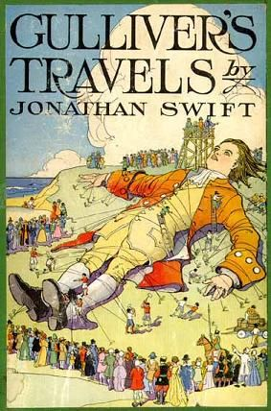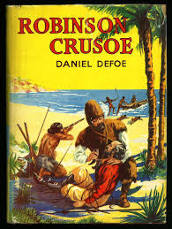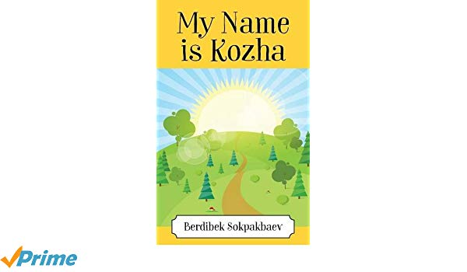
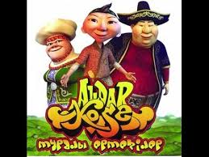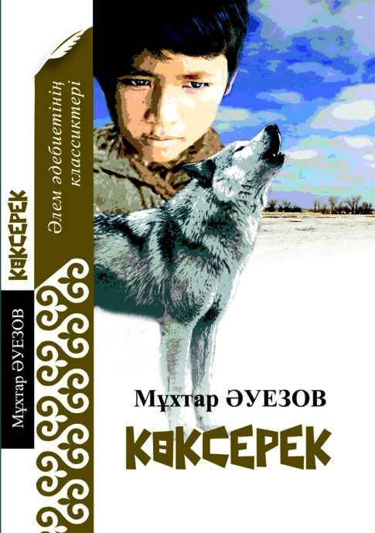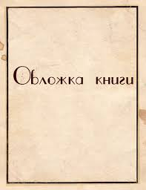
Other book which you read
Pictures were taken from:
https://www.google.kz/ swift+gulliver+book+cover
https://www.google.kz/ robinson+crusoe+book+cover
https://www.google.kz/.Kozha+Berdiek&gs_l
https://www.google.kz/.Aldar_Kose&gs_l
https://www.google.kz/.Kokserek+Auezov&gs_l

Name of the book and author, characters, type.
_________________________________________________________________________________________________________________________________________________________________________________________________________________________________________________________________________________________________________________________________________________________________________________________________

Write main idea of the book (summary).
_________________________________________________________________________________________________________________________________________________________________________________________________________________________________________________________________________________________________________________________________________________________________________________________________

Likes and dislikes of the book.
_________________________________________________________________________________________________________________________________________________________________________________________________________________________________________________________________________________________________________________________________________________________________________________________________

Reasons whom and why recommend the book .
______________________________________________________________________________________________________________________________________________________________________________________________________________________________________________________________________________________________________________________________________________________________________________________________________________________________________________________________________________

Total [6]

SPEAKING

Task. Work in pairs. You have some time to read your story. Don’t show it to your partner. Retell the story to your partner. You should include your ideas while telling it. You will be given 1 minute to prepare your talk and then 1-2 minutes to speak. Your pair ask questions on the topic. Swap the roles.

Learner A
Tsunami
https://www.eslprintables.com/vocabulary_worksheets/environment_and_nature/tsunami/Reading_Tsunami_Survival_Sto_470736/ (The text is adapted)

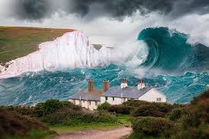

When Ari Afrizal went to wor on December 26th, 2004, he had no reason reason to expect anything unusual. Unfortunately, it was the day the deadly tsunami struck countries all round the Indian Ocean. Even worse, Ari was in the Aceh province of Indonesia, one of the areas hardest hit by the disaster.
Ari and his colleagues were working on the construction of a house when the tsunami struck. When they saw the giant wave approaching unexpectedly, swallowing everything in its way. They dropped their tools and ran as fast as they could toward a nearby hill. The wave caught up with them quickly, pushing them swiftly inland before pulling them back out to sea. Ari was separated from his companions and spent the next days drifting in the water alone. He floated until the next day when he saw a small boat. Ari found some clothes and a container of fresh water in it. He stayed there for several days. Nobody saw him. One day, a large ship came by and Ari waved and whistled at it. The ship picked him up and took him safely to land. Ari had been floating alone at sea for two weeks. No other tsunami survivor had been at sea that long.

Learner B
Volcano
https://www.google.kz/search?short+text+about+volcano+for+pre+intermediate+worksheets&oq=short+text+about+volcano+for+pre+intermediate+worksheets&gs_ (The text is adapted)

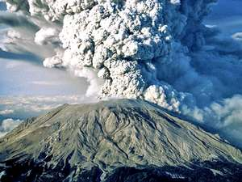
Today is August 24, AD 79. We are in Pompeii, small town in Italy. The town lies just below Mount Vesuvius, an ancient volcano.
Maximus Minimus walks past – he lives behind the bakery. He invites us in. We follow him into his open air courtyard. His wife, Agrippina, is here, writing a letter. A dog is sleeping in the corner.
Suddenly there is an explosion. The sky goes dark. The ground shakes violently. There is lightning. Everybody thinks it’s an earthquake, but it was the volcano. After 800 years, Mount Vesuvius has woken up. Fire and lava burst out of the top. Black clouds of hot ash fill the sky and the wind takes them over Pompeii. Maximus grabs Agrippina’s hand and they run out of the house. The dog hides under a table. Children cry. Most of people escape but two thousand die. When it is over, the sky stays dark. Piles of ash cover everything. It looks like snow.

Learner A
Earthquake
https://en.islcollective.com/english-esl-worksheets/grammar/modals/earthquakes-danger-californie/87846 (The text is adapted)

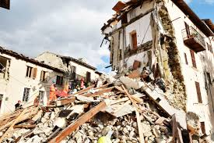

Ten things to remember during the earthquake
1.Take shelter under the table or desk. If you stand in a door frame, remember that doors can slam closed.
2. Go outside only if you are sure no power, lines or objects will fall on you.
3.Use stairs, not elevators.
4. Turn off the gas and water to stop lakes or floods.
5.Keep an emergency kit. Some people keep bicycles. If the roads are closed and there is no public transport, a bicycle is a good idea.
6.Keep food and water. You need enough water for 72 hours.
7. Put posters, not paintings on the walls. They are not dangerous if they fall.
8. Attach water heaters to the wall.
9. Respect the new building codes, which are designed for more security. Homes should be attached to their foundations. Walls should be reinforced.
10. There is another solution: move to the eat coast.

Learner B
Hurricanes
https://www.google.kz/search?short+text+about+flood+for+pre+intermediate+worksheets (The text is adapted)

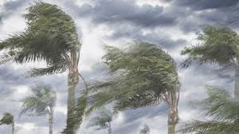
A hurricane is a very powerful rotating storm, also known as a typhoon or a cyclone. These storm can be huge, creating immense damage. These storms usually occur in America, the Gulf of Mexico and the Caribbean.
A storm is usually classified as a hurricane when the wind speed reaches over 74 miles per hour. A hurricane is accompanied with heavy rainfall.
The center of the hurricane is known as the eye of the storm. During a hurricane trees can be uprooted, roofs can be blown off houses and windows can be broken. It is advisable to stay indoors during a hurricane.
The UK doesn’t usually have hurricane storms. The worst storm in the UK since 1703 happened in 1987. A violent storm hit Southern England with winds reaching 122 miles per hour. I wasn’t hurricane, but millions of trees were uprooted, roads were blocked with fallen trees and hundreds of homes lost their roofs.

Total [6]

Total marks _/24

Mark scheme
Listening and Reading

№ | Answer | Mark | Additional information
1  2  3  4  5  6 | Think before you post. | 1
1  2  3  4  5  6 | Avoid send hurtful massages. | 1
1  2  3  4  5  6 | Don’t tell your location to everyone | 1
1  2  3  4  5  6 | Be careful with time. | 1
1  2  3  4  5  6 | to check their friends’ status updates, to post their own, to IM, to chat, to share photos | 1
1  2  3  4  5  6 | Websites and apps | 1
1  2  3  4  5  6 | False | 1
1  2  3  4  5  6 | False | 1
1  2  3  4  5  6 | False | 1
1  2  3  4  5  6 | True | 1
1  2  3  4  5  6 | There were sick people | 1 | Sentences structure can vary, but the meaning should be the same. F.e.  there were epidemics
1  2  3  4  5  6 | The summer had been dry, a hot east wind blew | 1 | Sentences structure can vary, but the meaning should be the same.
Total |  | 12

Mark scheme
Writing and Speaking

CRITERIA FOR MARKING WRITING

Give points out of 6 for each criterion (content, organization, vocabulary and grammar and punctuation), and then calculate a mean to give a total mark out of 6. All fractional marks should be rounded up to the closest whole mark.

Mark /  Criterion | Content (relevance and development of ideas) | Organization (cohesion, paragraphing and format) | Vocabulary (style and accuracy) | Grammar (style and accuracy) and Punctuation (accuracy)
6 | - All content is relevant to the task.  - The register completely corresponds to the requirements of the task; consistent and intentional misuse of register* may indicate a writer’s personal style.  - All content points are fully addressed and developed in a balanced way.  *Such misuse of register should not harm the format of writing. | - Uses a range of basic connectors correctly and attempts to use referencing, but not always clearly or appropriately.  - Uses paragraphs to separate ideas; all paragraphs revolve around one idea or a set of like ideas; the size of each paragraph allows for a proper and balanced development of ideas.  - The format is appropriate, but may be modified for a better reading experience. | - Uses a range of everyday vocabulary appropriately; attempts to use less common lexical items with occasional inappropriacies.  - Has good control of word formation; may make occasional errors in producing less common word forms.  - Spells common vocabulary items correctly; very few (one or two) occasional spelling mistakes may be present.  - May occasionally misspell less common lexical items.  - Errors in word choice and/or spelling do not distort meaning. | - Writes simple and compound sentence forms correctly and demonstrates some variety in length.  - May attempt some complex sentences, but they tend to be less accurate, including punctuation.  - Errors in grammar and/or punctuation do not distort meaning.
5 | - All content is relevant to the task; insignificant content omissions may be present.  - The register on the whole corresponds to the requirements of the task; occasional and inconsistent misuse of register may be present.  - Most content points are addressed, but their development may be slightly imbalanced. | - Uses a range of basic connectors correctly.  - Uses paragraphs to separate ideas; most paragraphs revolve around one idea or a set of like ideas; the size of each paragraph may reflect imbalanced development of ideas.  - The format is appropriate. | - Uses a range of everyday vocabulary appropriately; attempts to use less common lexical items, but may make frequent errors.  - Has good control of word formation; may make errors in producing less common word forms.  - Spells common vocabulary items correctly; few (no more than five) occasional spelling mistakes may be present.  - May often misspell less common lexical items.  - Errors in word choice and/or spelling do not distort meaning. | - Writes simple and compound sentence forms correctly, but does not demonstrate variety in length.  - Occasional errors in grammar and/or punctuation do not distort meaning.
4 | - Most content is relevant to the task; insignificant content omissions may be present.  - The register on the whole corresponds to the requirements of the task.  - Most content points are addressed, but some content points may be more fully covered than others. | - Uses some basic connectors, but these may be inaccurate or repetitive.  - Uses paragraphs to separate ideas, but tends to misuse paragraphing (a script is a set of very short paragraphs or some paragraphs may be much longer than other ones for no apparent reason).  - The format is generally appropriate. | - Uses everyday vocabulary generally appropriately, while occasionally overusing certain lexical items.  - Has good control of word formation; can produce common word forms correctly.  - May make infrequent errors in spelling more difficult words.  - Errors in word choice and/or spelling rarely distort meaning. | - Writes simple and some compound sentence forms correctly.  - While errors in grammar and/or punctuation are noticeable, meaning is rarely distorted.
3 | - Some content is relevant to the task; significant content omissions may be present.  - The register barely corresponds to the requirements of the task.  - Only some content points, which are minimally addressed. | - Uses a very limited range of basic cohesive devices correctly.  - Writes in paragraphs, but may not use them to separate ideas (a script may have random breaks between paragraphs).  - The format may be inappropriate in places. | - Uses basic vocabulary reasonably appropriately.  - Has some control of word formation; can produce some common word forms correctly.  - Makes frequent errors in spelling more difficult words, but simple words are spelled correctly.  - Errors in word choice and/or spelling distort meaning at times. | - Writes simple sentence forms mostly correctly.  - Errors in grammar and/or punctuation may distort meaning at times.
2 | - Severe irrelevances and misinterpretations of the task may be present.  - Only few content points, which are minimally addressed. | - May use a very limited range of basic cohesive devices, and those used may not indicate a logical relationship between ideas.  - Attempts to write in paragraphs, but their use may be confusing (may start every sentence with a new line).  - The format may be inappropriate. | - Uses an extremely limited range of vocabulary.  - Has very limited control of word formation; can produce a few common word forms correctly.  - Makes many errors in spelling, including a range of simple words.  - Errors in word choice and/or spelling distort meaning. | - Writes some simple sentence forms correctly.  - Frequent errors in grammar and/or punctuation distort meaning.
1 | - Attempts the task, but it is largely misinterpreted and the response is barely relevant to the task. | - Links are missing or incorrect.  - Does not write in paragraphs at all (a script is a block of text).  - The format is not appropriate. | - Can only use a few isolated words and/or memorized phrases.  - Has essentially no control of word formation; can barely produce any word forms.  - Displays few examples of conventional spelling. | - No evidence of sentence forms.
0 | - Does not attempt the task in any way.  OR  - The response is completely irrelevant to the task.  OR  - There is too little language to assess.  OR  - Content is completely incomprehensible due to extremely poor handwriting: very few words are distinguishable, so there is a lack of context to verify meaning.

CRITERIA FOR MARKING SPEAKING
Give a mark out of 6 for each criterion (development and fluency, and language), and then calculate a mean to give an overall total out of 6.
Mark /  Criterion | Development and Fluency | Language
6 | - Shows sustained ability to maintain a conversation and to make relevant contributions at some length.  - Produces extended stretches of language despite some hesitation.  - Can respond to change in direction of the conversation.  - Pronunciation is intelligible*.  - Intonation is appropriate. | - Produces error-free simple sentences.  - Attempts some complex grammatical forms, but may make errors, which rarely cause comprehension problems.  - Uses a range of appropriate vocabulary to give and exchange views on a growing range of general and curricular topics.
5 | - Responds relevantly and at length which makes frequent prompting unnecessary, resulting in a competent conversation.  - Produces mostly extended stretches of language despite some hesitation, although instances of using short phrases may be present.  - Can generally respond to change in direction of the conversation.  - Pronunciation is generally intelligible.  - Intonation is generally appropriate | - Produces error-free simple sentences.  - Uses a range of appropriate vocabulary when talking about a range of general and curricular topics.  - Occasional mistakes do not cause comprehension problems.
4 | - Attempts to respond to questions and prompts.  - Produces responses which are extended beyond short phrases, despite hesitation.  - Effort will need to be made to develop the conversation; only partial success will be achieved.  - Pronunciation is mostly intelligible.  - May not follow English intonation patterns at times. | - Frequently produces error-free simple sentences.  - Uses appropriate vocabulary to talk about a limited range of general and curricular topics.  - Errors may cause comprehension problems.
3 | - Responses tend to be brief and are characterized by frequent hesitation.  - Has to be encouraged to go beyond short responses and struggles to develop a conversation.  - There is a lack of intelligibility of pronunciation, but it is unlikely to impede communication.  - May not follow English intonation patterns frequently. | - Produces basic sentence forms and some correct simple sentences.  - Uses a limited range of appropriate vocabulary to talk about a limited range of general topics.  - Errors are frequent and may lead to misunderstanding.
2 | - Responses are so brief that little is communicated.  - Barely engages in a conversation.  - Pronunciation may cause some communication difficulty.  - Does not follow English intonation patterns. | - Attempts basic sentence forms, but with limited success.  OR  - Heavily relies on apparently memorized utterances.  - Uses a limited range of appropriate vocabulary to talk about a very limited range of general topics.  - Makes numerous errors except in memorized expressions.
1 | - No communication possible.  - Pronunciation and intonation patterns cause difficulty for even the most sympathetic listener. | - Cannot produce basic sentence forms.  - Can only produce isolated words and phrases or memorized utterances.
0 | - No attempt at the response.  OR  - No rateable language.
*Speech deficiencies should not be considered as affecting intelligibility.
Only for teachers! Transcript for listening task: Five social media musts for teens.

Teens today are spending tons of time on social media. They like to check their friends’ status updates, to post their own, to IM, to chat, to share photos and more.
Here are five social media musts to share with your teen before they post.
First, use privacy settings. Most websites and apps allow you to control who sees your posts and locations. It’s a good idea to limit it to people you know.
Next, think before you post. Even the best privacy settings aren’t foolproof. Friends can tag, copy, take a screenshot, forward and share what you post. And you never know where things will end up.
Third, be respectful. Never forward hurtful messages or embarrassing photos, and impersonating other people is a definite no-no.
Fourth, be careful about revealing your location. Although it might be tempting to use location capabilities to connect with friends or brag about where you are, it’s not always a safe move.
And finally, watch the clock. Social media can be fun but it’s also a real time suck. Hours and hours can go by, which isn’t great for getting anything else done.

