Lesson plan
Module 5.Our health |  |  |  | School: Secondary school after K.Baisykov
Date: 17.01.2020 |  |  |  | Teacher’s name Baktiyarova K.Zh
Class: 6 a |  |  |  | Number present: | absent:
Theme of the Lesson: |  | Unit 3 Designing healthy menu. Countable and uncountable nouns and quantifiers.
Learning objective(s) that this lesson is contributing to |  | 6.1.1.1.-use speaking and listening skills to solve problems creatively and cooperatively in groups  6.6.2.1.- use quantifiers including more, little, few less, fewer not as many, not as much on a growing range of familiar general and curricular topics.
Lesson objectives |  | All learners will be able to:  - differ healthy/unhealthy food, countable/uncountable nouns & quantifiers, make menu  Most learners will be able to:  - ask and answer questions to recognize speaker’s opinion using quantifiers and create menu  Some learners will be able to  -to create a menu for healthy life and share with other classmates  -use quantifiers expressing opinions
Assessment criteria |  | - A learner can talk about healthy and unhealthy foods and their impact on people  - A learner can use quantifiers on a growing range of familiar general and curricular topics  - A learner can create a special menu for healthy life style.
Value links |  | Cooperation, respect to each other, collaborative work
Cross curricular links |  | Biology
Previous learning |  | Healthy food
Plan
Planned timings | Planned timings |  |  |  |  | Resources
Beginning  0-2  2-8 | Organizational moment  Greeting students.  -Good morning, my dear pupils!  Let’s make a circle, my dears!  Teacher sets positive atmosphere by asking such ice-breaking questions  -How are you?  -How is your mood?  Imagine that you are in restaurant and take napkins please.  Pupils take stickers how many they want.  -Now you must say some words wishes for this lesson.  Thank you, take your sit please!  Pay attention to our golden rules of group work.  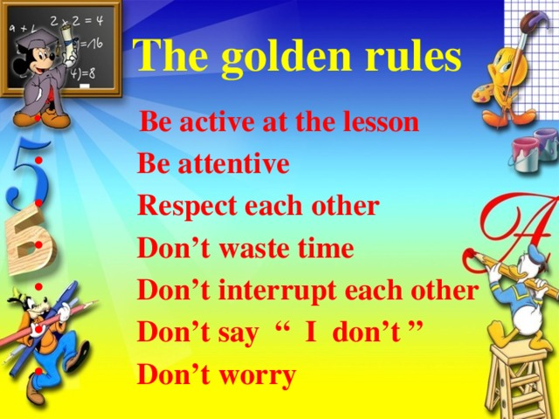  Teacher draws students’ attention to the title of the lesson and discusses Learning Objectives with the students.  Warm –up.  Ask learners if they or their parents choose what they eat. Which do you think is better?  Checking up hometask.  Үй тапсырмасын тексеру (кинометафора әдісі)  -What was your homework for today’s lesson?  -Yes, you are right!  -I gave you to prepare video with parents about healthy food. We have three groups  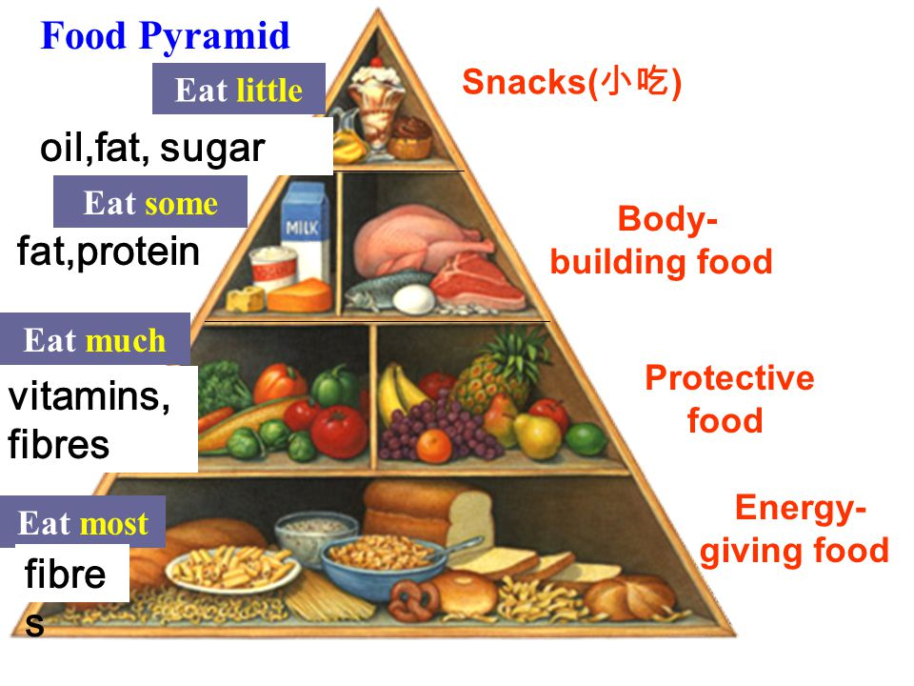  1. Energy giving food  2. Protective food  3. Body building food  Cards with questions about video  You must assess each other.”Three cards”  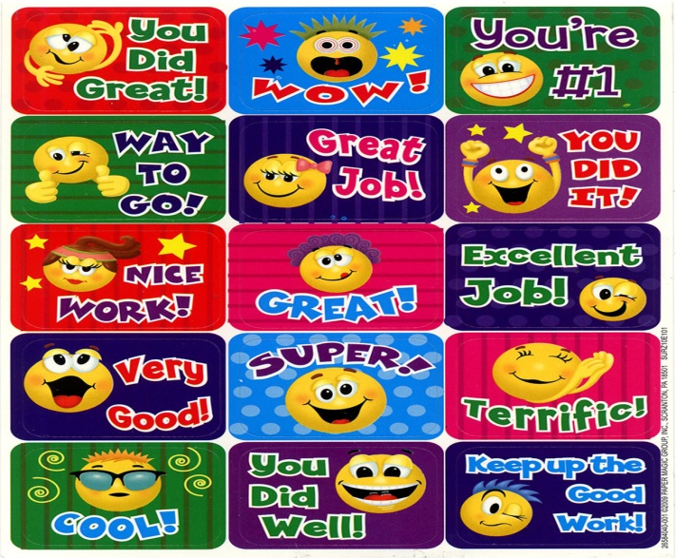 |  |  |  |  | PPT slides 1-2
Middle  7-12  12-17  17-20  20-25  25-35 | 1st task  You see there different products in our supermarket.  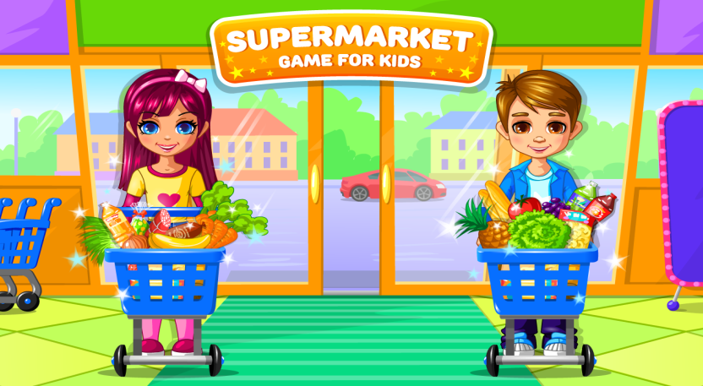  And the next task for you.  For the first group – to find healthy food.  Second group-unhealthy food.  Third group-diary products.  Топтар өз себеттеріне қажетті тағамдарды жинап алады.  Countable, uncountable nouns quantifiers  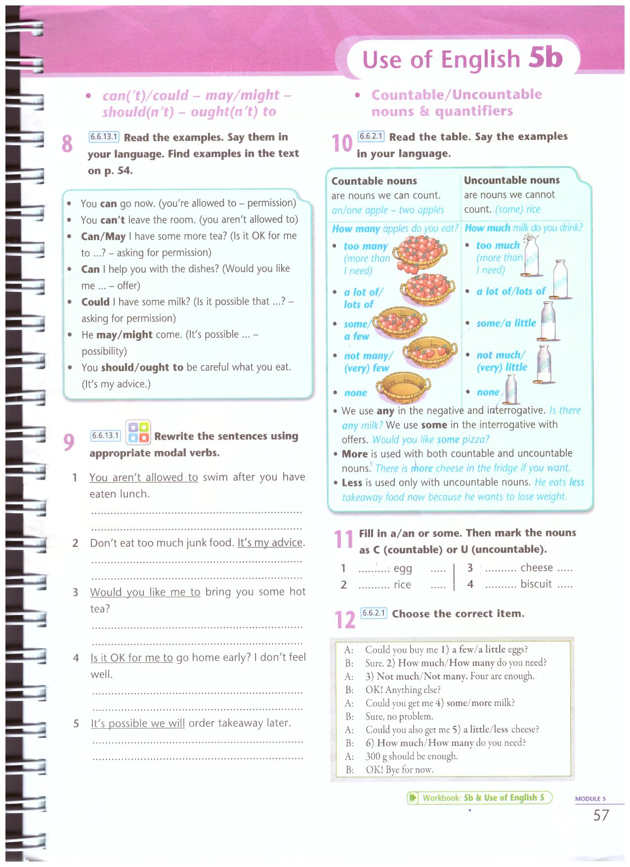  To brainstorm how to use too much, too many and not enough, show a video to students. It is highly recommended to show the video, because learners have to use quantifiers in speaking activity.  Learners think about their typical diet and decide if it is healthy. They should refer to the healthy eating pyramid. They must identify five foods they should eat less of, and five foods they should eat more of. They discuss their choices with their partner. Encourage them to use phrases like too much/many and not enough.  .2nd task  Now you must find from your products «countable and uncountable nouns».  Descriptor A learner  *Differ healthy/unhealthy food  *differ countable/uncountable food  *know quantifiers  Ex.11,12 p.57  3rd task  «Scrambled eggs» method  You must find different colourful cards with tasks from this eggs.You must choose and do this tasks.  Descriptor A learner  *revise grammar rules  *find right answers  Бағалау дискрипторы ұсынылады.  Focus on writing  Learners plan a healthy life lunch menu for a school for five days. Show a video  (Gallery method)  Each group must make healthy menu. They will need to choose a main course,side dishes, dessert and drink for one day.  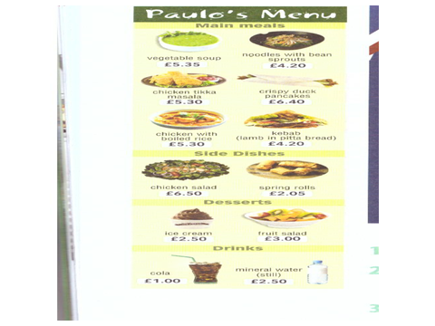  Focus on speaking  I Explain that they should try to include plenty of different foods and make the menu appealing for teenagers.  Presentation  They present one day of their menu to the rest of the class (or to groups if this would take too long.) The class makes comments on whether the choice of food is tasty, healthy, expensive or suitable for vegetarians.  Assessment “2 star,one wish” |  |  |  |  | Pair work and group work  Multi-level photocopiable activities for teenagers  PPT Slide 3/4  Video  PPT Slide 3  Pair work and group work
End  35-40 | Feedback  Assessment  Try harder Good Excellent  I know healthy/unhealthy food  I can use quantifiers  I can make healthy menu  At the end of the lesson, learners reflect on their learning:  - What have we studied today?  - What did you find difficult?  You see spoons on the table.Now you must to express your mood today’s lesson by drawing  -The lesson is over! Good bye! |  |  |  |  | Posters  Spoons

