LESSON10: Holidays and travel  Unit |  |  | School: Yeltay secondary school
Date: 18.02.20 |  |  | Teacher name: AlievaA.E.
Grade: 6a |  |  | Number present: 10 |  |  |  | absent:0

Theme of the lesson: My country: An adventure holiday
Learning objectives(s) that this lesson is contributing to |  |  | 6.S2 ask simple questions to get information about a limited range of general topics  6.L4 understand the main points of supported extended talk on a range of general and curricular topics  6.R5 deduce meaning from context in short texts on a limited range of familiar general anf curricular topics
Lesson objectives |  |  | All learners will be able to:  - Identify basic information;  Most learners will be able to:  - Identify basic information and answer to the questions  Some learners will be able to:  - Identify basic information and to share with some ideas
Assessment criteria |  |  | - Identify an increasing range of supported questions;  - Answer to the questions;  - Explain the text in written form;
Value links |  |  | education in a multilingual society of free well-being
Cross-curricular links |  |  | Geography
Previous learning |  |  | How was your weekend?
Plan
Planned timings | Planned activities |  |  |  |  | Resources
Beginning  5 min  (S) | Greeting/ Greet learners and ask them take their places;  - Ask learners how they are today and what day it is today, days of the week.  - Checking up the hometask  Warming up  Task. ‘Four pictures and one word’  Task ‘Match the words with the pictures’  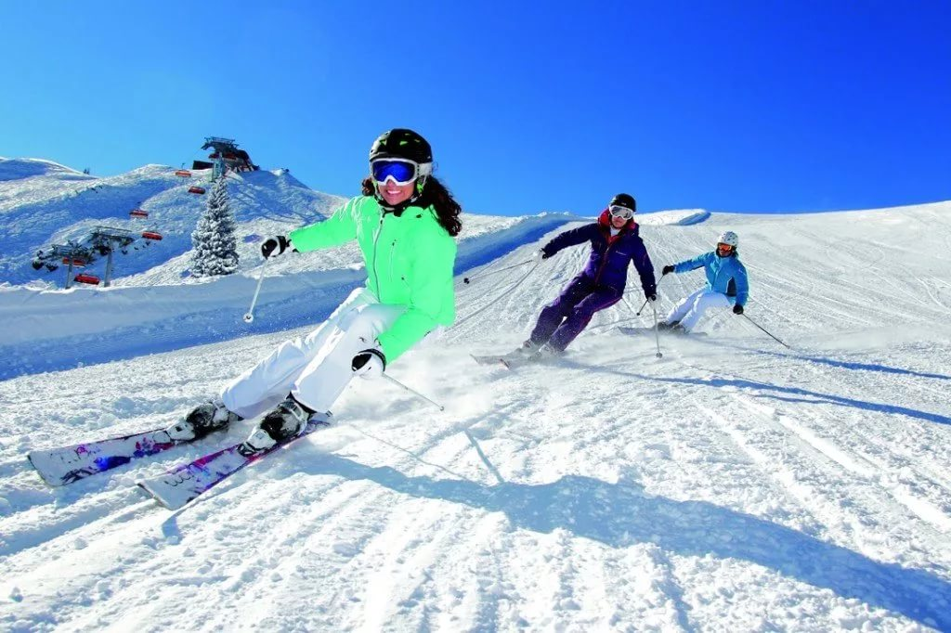Answer the questions  - Which is your favorite type of holiday? Why?  - Who do you go on holiday with?  - Look at the photo in the text. Would you like to go on this type of holiday?  FA: T says “Very well” and motivate pupils. |  |  |  |  | Whiteboard
Middle  15 min  (L/S)  10 min  (R)  5 min  (L\S) | T: Repeat new words after me  A white – water adventure – су сапарлары  Raft –қайық  Beginner - бастаушы  Advanced – озық  Flow – ағын  Offer – ұсыну  Increase – күшейту  Countryside – аймақ  Wildlife – жабайы аймақ  Task1 Read the text ‘A white – water adventure’  FA: T says “Very well” and motivate pupils.  Task 2 PW: to find these sentences in English from the text  - Егер сіз шытырмаған оқиғаны ұнатасаңыз, онда су сапарлары сізге лайықты болуы мүмкін.  - Әрине сіз су боласыз, сондықтан сізге жүзуге арналған арнайы киім кию керек.  - Рафтинг (су спорты) - тамаша спорттың бір түрі.  - Сізде біршама тәжірибе болғандықтан, қауіптілігі одан да жоғары су сапарына шығуыңыз мүмкін.  FA: T says “Very well” and motivate pupils.  Task 3 IW: Work with students book Ex2 p76 Read the text and write true or false. Correct the false sentence  1. False. Children can try it if they are with an adult  2. True  3. False. You will get.  4. False. You should wear a swimming costume under your clothes, such as shorts or tracksuit bottoms and a sweatshirt.  5. True  6. False. It is a more difficult river.  FA: to give smiles and motivate pupils.  Task 4 IW: Ex4 p76 Work in pairs.  Ask and answer the questions using could, might and may  - We may go to Tabagon.  - We might go and see a film.  - I’m not sure, I might fall in.  - The rock could be dangerous if it rains.  - I think, it may rain.  - It might not be bad.  FA: to give smiles and motivate pupils. |  |  |  |  | Whiteboard, cards  Book  Book and Whiteboard  Book
End  5 min | Now let’s time for reflection ‘Butterflies’  Green: I understood the lesson  Yellow: I understood but I have some questions  Pink: The lesson wasn’t clear
Additional information
Differentiation – how do you plan to give more support? How do you plan to challenge the more able learners? |  | Assessment – how are you planning to check learners’ learning? |  |  | Health and safety check  ICT links
Less able students – greater support by means of prompts, visuals or writing difficult words on the blackboard
More able students – independent work on definite tasks with little/no support

While group or pair work more able students can also provide less able students with additional support
Reflection
Were the lesson objectives/learning objectives realistic?
What did the learners learn today?
What was the learning atmosphere like?
Did my planned differentiation work well?
Did I stick to timings? What changes did I make from my plan and why?
Summary evaluation
What two things went really well (consider both teaching and learning)?
1:
2:
What two things would have improved the lesson (consider both teaching and learning)?
1:
2:
What have I learned from this lesson about the class or individuals that will inform my next lesson?

