«Сасан би атындағы орта мектеп» КММ

Ашық сабақ
«Having fun»

Пән мұғалімі: Амирова Балжан
Сынып: 5

2019- 2020 оқу жылы
Lesson plan

LESSON:  Module 4.  Step 1. |  |  |  |  | School: “Secondary school named after Sasan bi”
Date:21/02/2020 |  |  |  |  | Teacher name: Amirova B
Theme of the lesson |  |  |  |  | Having fun
CLASS: 5 |  |  |  |  | Number present: |  | absent:
Learning objectives(s) |  |  | 5. S6 communicate meaning clearly at sentence level during, pair, group and whole class exchanges  5.L5 to understand by ear a short text based on a familiar language material or based on an image.
Lesson objectives |  |  | All learners will be able to:
 |  |  | - can tell about the activities they are interested in
 |  |  | Most learners will be able to:
 |  |  | - Make a sentences
 |  |  | Some learners will be able to:
 |  |  | - understand most of the language used by the teacher at the lesson
Language  objectives |  |  | Imperatives and sequences , environment vocabulary
Value links |  |  | Respect, Cooperation
Cross curricular  links link |  |  | Biology Environment
ICT skills |  |  | Projector or Smart board for presenting a PPT
Previous learning |  |  | Learners learned about the environment problems at the previous lesson so they should be familiar with some vocabulary on this topic.
Plan
Planned timings |  | Planned activities |  |  |  |  |  |  |  | Resources
Lesson I
Start  10 min  Middle  20 min.  5 min | Good afternoon my dear pupils!  Answer to my questions.  - Good morning! How are you? What is the date today? Who is absent?  Warm-up:  Before we`ll begin our lesson answer my question, please.  -How are you today?  Hello, hello, hello!  How are you?  Hello, hello, hello!  How are you?  I’m fine, I’m grade, I’m wonderful  I’m fine, I’m grade, I’m wonderful  Checking- up the home task. There is/There are construction and prepositions.  There is a bird on the house.  There is a door next to window  There is a door in front of house.  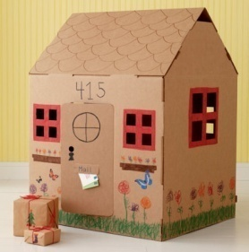  there are flowers on the left the house  there is a window above the flowers.  There is a ball in the house.  There are two windows behind the house  There is a spider on the right the house  There are trees near the house  There are 5 rooms  There is garden in front of house  Describter: Make right sentences;  Clue the sentences  Verbal assessment: You’re active and don’t make mistake; You’re active but have some mistake; You weren’t so active and lots of mistakes.  Grouping. I want divide you into two groups. Dividing with sweets.  The main part of the lesson.  Today we`ll speak about modal verb “can”, make up dialogues and do some exercises.  First of all let`s introduce our new vocabulary. Look at the blackboard and repeat after me.  Speaking. Task.2. Students look at the pictures on the slide and make a sentence. Individually work  Draw, play basketball, play computer games, ect…  For ex: I can play football. I can dance….  Describter: maka a sentences:  Listening. Task 3. Activity “BeeNest”. The group goes outside the door. The second group watch the video. Then the group members explain a couple of the following members of the group about video. Pair work  Text of the video.  Hi, I'm Alex. I am nine.  I like sports. I can play football and I can play basketball.  I can jump and I can run very fast. I can swim very well.  But I can't draw and I can't sing.  2.  Hello! My name is Ann. I am nine.  I like music. I can sing and I can dance very well.  I can draw pictures of cats. I like cats!  I can ride a bike and I can run but I can't jump very well.  Assessment “What taste”  Differentiation  . “Who can...?” teacher gives tasks  for “C” learners: Talk about your friend    “B” learners: Talk about yourself  “A” learners: What can you do?  Speaking. Students fill out the table on their hands using each other's questions. It turns out who has good abilities and what can they do?  Can you…? ----- ----- ----- -------  Sing?  Dance  Fly  Ride a bike  Play football  Swim  Run  Jump  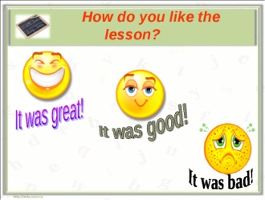assess by learners emotion.  Poetry break. During the poetry break, students throw a ball and recite passages from Abay's poems by heart.  Task for formative assessment. |  |  |  |  |  |  | https://yandex.kz/video/preview/?filmId=10506228008248125272&text=hello%20s  Pictures on the board  Slide 1  Video 1  http://learnenglishkids.britishcouncil.org/en/songs/its-up-me-and-you  Video 2  http://learnenglishkids.britishcouncil.org/en/songs/its-up-me-and-you  Handout 1  Handou 2
End  5 min | 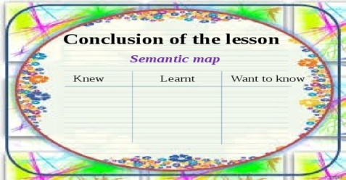  Assessment – students assess themselves using technique “Semantic card” and dtaw on the paper your emotion about lesson.  The teacher will give feedbach for lesson, and give them emotions.  Homework. To write an essay about your friends. |  |  |  |  |  |  |  | Handout 3
Additional information
Differentiation – how do you plan to give more support? How do you plan to challenge the more able learners? |  |  |  | Assessment – how are you planning to check learners’ learning? |  | Cross-curricular links  Health and safety check  ICT links  Values links
- More support can be given at the start and in middle of lesson by providing less-able learners with some vocabulary on the board so they can read examples of words seen or heard.  - Divide students so that in each group were less able and more able students.  - More able students can support less able students |  |  |  | - Monitor how clearly learners pronounce words and sentences.  - Notice any sentences which are difficult for learners to understand and adapt for a future lesson.  - Monitor pair and group work as they agree on and prepare the recipes. Do they take turns to speak? Do they contribute appropriate language during discussion?  - Assessment – students assess each group using technique “semantic card” |  | - Links to the L1: Do learners use the same form of imperatives in their native language L1?  - Make sure all learners have a copy of lyrics to read and learn.  - PPT  - Respect and cooperation
Reflection  Were the lesson objectives/learning objectives realistic?  What did the learners learn today?  What was the learning atmosphere like?  Did my planned differentiation work well?  Did I stick to timings? What changes did I make from my plan and why? |  |  |  | Use the space below to reflect on your lesson. Answer the most relevant questions from the box on the left about your lesson.
Summary evaluation

What two things went really well (consider both teaching and learning)?

1:

2:

What two things would have improved the lesson (consider both teaching and learning)?

1:

2:

What have I learned from this lesson about the class or individuals that will inform my next lesson?

